**How to accept insecure certificates in Firefox?**

In firefox also you will see the insecure certificates error.

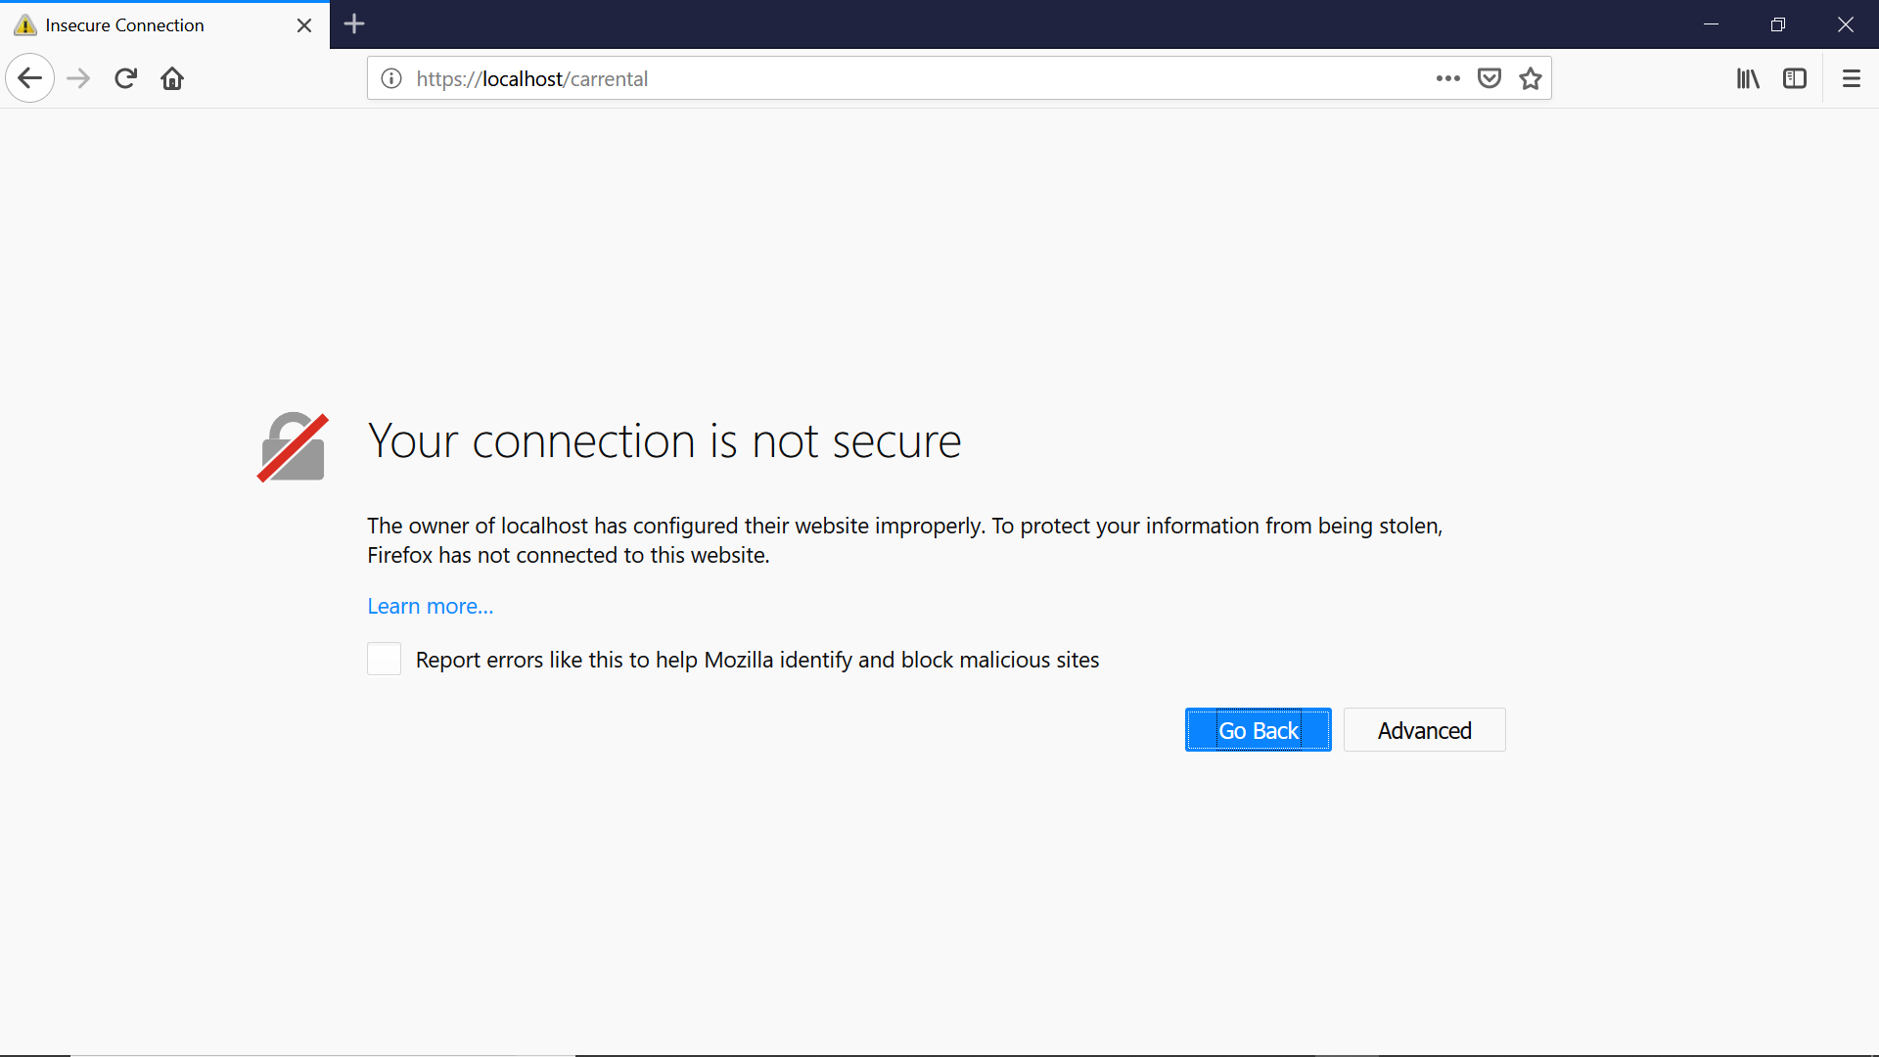

**package** Selenium;

**import** org.openqa.selenium.WebDriver;

**import** org.openqa.selenium.firefox.FirefoxDriver;

**import** org.openqa.selenium.firefox.FirefoxOptions;

**public** **class** AutomationBar {

**public** **static** **void** main(String[] args) {

System.*setProperty*("webdriver.gecko.driver", "C:\\BrowserDrivers\\geckodriver.exe");

FirefoxOptions fo = **new** FirefoxOptions();

fo.setAcceptInsecureCerts(**true**);

WebDriver driver = **new** FirefoxDriver(fo);

driver.manage().window().maximize();

driver.get("https://localhost/carrental");

}

}